Healthy Bytes Article
Aug 2018 Tomatoes

Sumptuous Summer Tomatoes
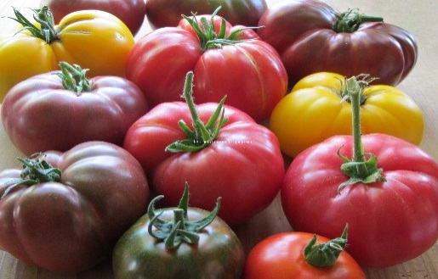
By Stephanie Polizzi, MPH, RDN

There’s nothing like a fresh slice of bright red summer
tomato for your sandwich or salad. But did you know
that tomatoes can also come in yellow, orange, green
and even purple? Chlorophyll and carotenoids are
responsible for the color of tomatoes, but they are also
the compounds that contribute most to our health.

Botanically, tomatoes are fruits, not vegetables, but that doesn’t affect their ability to fight disease. Tomatoes are high in a variety of antioxidants that protect us from heart disease, stroke and several types of cancer. They contain high amounts of vitamin C and beta carotene which protect our skin, eyes and immune system. They also contain potassium which lowers blood pressure and vitamin K which assists with blood clotting. Both help keep your bones strong. Other antioxidants like lutein and zeaxanthin maintain eye health.

Of all the protective compounds found in tomatoes, lycopene, a pigment and antioxidant, may be the most important. This is the most abundant carotenoid found in ripened tomatoes which has been shown to prevent risk of prostate, lung, pancreatic and stomach cancers. Studies show that lycopene may also help lower cholesterol. The highest levels of lycopene are found in the peels or skins of the fruit, and cooking increases availability. Processed tomato products, like sauces and ketchup, account for 80% of the lycopene consumed by Americans. Another antioxidant found in tomato skins is naringenin which has been shown to protect against chronic inflammation.

One thing to note is that commercially-grown tomatoes are among the top 10 food products to contain high levels of pesticide residue. Buying organic is an option for some, but can get expensive. One way to reduce pesticides is to soak tomatoes (or other fruit) in a solution of 4 parts water to one part white vinegar for 10 minutes. Rinse well before serving. Or you can consider growing your own tomatoes in containers on your patio. Any container will do, even hanging planters. Drill holes for water drainage in a 5-gallong container to give your plant a great home. Cherry or dwarf varieties of tomatoes do well in containers. They like 6-8 hours of full sun and protection from the wind. Plant marigolds near the plants to keep bugs away. Give them a post for the vines to climb and water daily in the mornings.

Get more tomatoes in your diet by tossing raw into salads, sliced on sandwiches or chopped into salsas. Puree or chop and toss into soups, stews or sauces. You can freeze or can tomatoes for year-round use. Or puree with oregano and basil and dehydrate to make a delicious pizza fruit leather your kids will love.

