Healthy Bytes Article
Sep 2018 Oats

Hearty Oats
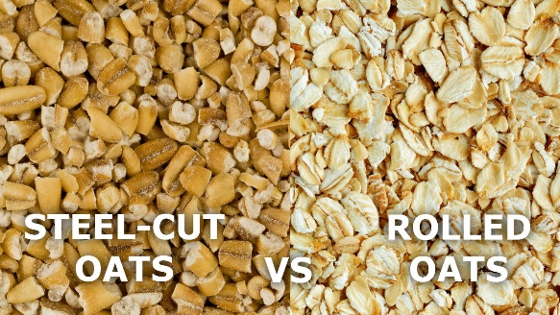
By Stephanie Polizzi, MPH, RDN

As we move into the fall season, warm, hearty foods
like oats, take center stage. Oats have been a staple in
our diet for thousands of years. They are a good fuel to
keep us feeling full and energized. Oats are high in
protein and have more soluble fiber than any other
grain. This fiber helps lower blood sugars and
cholesterol. Oats can also help to reduce chronic inflammation. The greatest health benefits are derived from the least-processed varieties.

Varieties of Oats
Steel-cut oats use the whole oat kernels (called groats) that are chopped into smaller pieces. They have a firm texture, darker color and rich flavor. They can take 20 to 30 minutes to cook. A quick method is to put steel-cut oats in a pan with water and bring to boil. Then turn off the heat and add a lid. Come back in 30 minutes after your shower or walk and reheat in just minutes. Or you can soak overnight and heat in the microwave.
Scottish oats are steel-cut oats that have been ground, making them quicker cooking.
Rolled oats are the most common, also known as “original.” These are groats that have been sliced into flakes with steam. This partially cooks them so they cook faster. These oats can also be eaten as is, tossed in yogurt or on salads.
Instant or Quick-cooking oats have been processed to cook faster. This may seem like a convenience until you realized this also contributes to faster digestion. As a result, these options do not have the capacity to regulate blood sugar control. They also remove flavors of the rich taste of oat. Often this form has added flavorings, sugars and salt.
Oat flour is made from whole oats ground into a powder. You can make your own by grinding steel-cut oats, Scottish or rolled oats in your high-powered blender. Oats do not contain gluten so the flour does not rise.

Although oats are naturally gluten free, they may be processed on machinery with gluten products. Read labels carefully if you are trying to avoid gluten.

Oats are rich in nutritious vitamins and minerals, antioxidants and fiber. Add oats to muffins, pancakes or cookies for extra soluble fiber. Mix with peanut butter, almonds and honey to form oat balls. No cooking necessary! Or just enjoy oats for breakfast with different toppings such as blueberries or bananas. Stir in almond butter and top with coconut or walnuts, or add applesauce or fruit preserves. Spice it up with cinnamon, ginger or pumpkin spices. No matter how you eat your oats, adding this grain to your routine will give you a healthy start.

