Healthy Bytes Article
Oct 2018 Kale

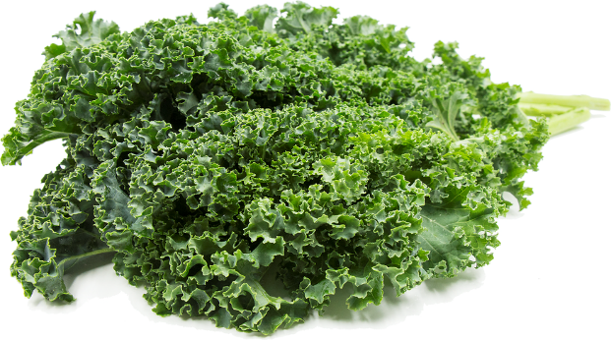
Go Green with Kale
By Stephanie Polizzi, MPH, RDN

When experts tell you to eat greens for good health,
they are probably talking about kale. It is among the most
nutrient-dense foods on the planet. Most popular is Curly
kale, which has firm, bright green, curled leaves and a
fibrous stem. But kale can also be purple, dark green, soft
or stiff, with smooth or pointed leaves. Other types include
Dinosaur, Red Russian and Redbor kale.

All kale varieties are rich in powerful antioxidants which protect against diseases like cancer and heart disease. Per calorie, kale has more iron than beef and more calcium than milk. Vitamin A, in the form of beta carotene, is good for vision and healthy skin. Kale has nearly 5 times as much as vitamin C as spinach, boosting immunity and maintaining collagen, which protects against aging. Vitamin K helps with blood clotting and strong bones.

The best way to consume kale is raw. Chewing kale helps release compounds that help your body make nitric oxide. This compound triggers arteries to widen and increase blood flow (vasodilation). Nitric oxide also helps the arteries stay smooth and elastic for better circulation. Improved nitric oxide production is associated with reduced risk of complications from heart disease, diabetes and inflammation.

Curly kale can be tough and bitter but this is easily resolved in a variety of ways. First, you could choose baby varieties which tend to be softer and sweeter. Another option is to sprinkle kale with 1-2 tablespoons of lemon juice or vinegar. Massage the greens like you were kneading bread until half the volume. This breaks down the toughness, removes the bitterness and brightens the color for an appetizing salad. Lightly sautéing (wilting) curly kale will also remove bitterness. Dinosaur kale has long dark green leaves, and is softer with a nutty sweetness. Russian kale, the type with pointed leaves, is much softer and does not require special treatment except to remove fibrous stems.

Besides using kale in salads or on sandwiches, it can be consumed in a variety of ways. Try adding a handful to smoothies or shakes. Bake or dehydrate with seasoning for chips that are actually good for you. Use as a side dish or toss into soups, casseroles or pasta dishes just before serving. Or try chopping into salsa or dips. You can also roast or grill kale with your favorite vegetables. Consider growing kale in your container garden for a year-round daily supply.

However you get your kale, be sure to add this powerful green to your healthy diet.

