Healthy Bytes Article
Mar 2019 Radishes

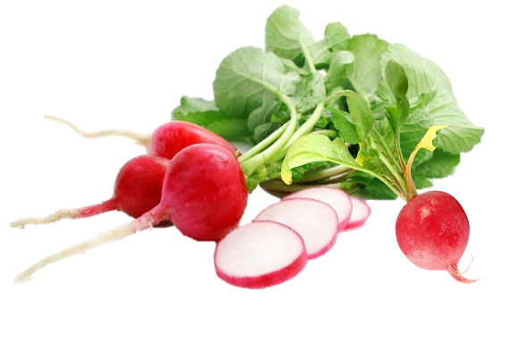

Red, Round Radishes
By Stephanie Polizzi, MPH, RDN

Most know radishes as thinly sliced red vegetables with
stark white interiors and a mild peppery taste. You most
often find them raw in salads. Radishes pack such a powerful nutrition
punch that the ancient Greeks made golden radish replicas to show their value.

The radish is a root vegetable, part of the brassica family, making it a close cousin to kale and cabbage. Like other brassica vegetables, it is prized for its antioxidant and anti-cancer potential. They contain indoles which are powerful detoxifying agents and sulforaphane. Both work together to inhibit many types of cancer. Radishes are high in vitamin C which helps fight free radicals that can lead to aging and disease. They boost immunity, lower blood pressure and can reduce the onset of painful gout. They are also high in B vitamins that help the body break down food for energy, and minerals like calcium and magnesium that help keep our hearts healthy. Plus, radishes may help lower cholesterol. Low in calories, radishes are a good source of fiber and have properties that help reduce inflammation in the urinary tract.

There are several varieties of radishes, the most nutritious of which are black radishes, which have the strongest, peppery taste. In the US, we commonly find round, red radishes, about the size of a ping-pong ball. You can also find round pink or purple radishes, or white, elongated varieties called daikons. Although the radish root is most often used, the green stems are also edible. Radish roots can be enjoyed raw, roasted or steamed and the greens can be consumed raw in salads or on sandwiches, or steamed in soups or as a side dish.

When buying radishes, the greens should be perky and bright, with no signs of yellowing. The roots should be free of holes or cracks, although slight blemishes are OK. The heavier fruit has the greatest concentration of moisture and juice so seek out golf-ball weight. The darker the color, the greater the nutrition value. If buying already bagged, check for mold as radishes are often kept moist for storage. The “snap” you hear when sliced indicates freshness.

To store, remove the green tops for immediate consumption. The greens do not last as long as the root. Wash and store the roots in an open plastic or paper bag, and place in the crisper section of your fridge. Consume within 7-10 days.

Besides using raw in salads, try pureeing raw radish roots with nuts or seeds, olive oil and spices for a tangy pesto. Add to dips or hummus or just use whole for dipping. Cut partway through the root and soak in water to make radish “roses” as edible art. However you use radishes, making them part of your daily diet will help keep you and your family healthy.

