Healthy Bytes Initiative Article
Jun 2019 Tofu

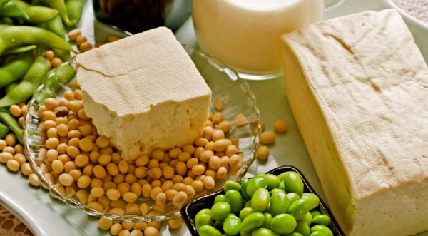

Versatile Tofu
By Stephanie Polizzi, MPH, RDN

Tofu is a soy product pressed from the boiled mature
soy beans, a process similar to making cheese. It is an
excellent source of protein and can be substituted
for meat since it contains all 9 essential amino acids. Tofu is naturally gluten free, contains no cholesterol and costs less than most cuts of meat.

Soy contains isoflavones which are plant-derived hormones. Studies show 25 grams of soy products per day has been found to reduce cholesterol, decreasing risk for heart disease and stroke. In addition, isoflavones may help reduce symptoms of menopause. Genistein, another type of isoflavone, acts as an antioxidant to inhibit the growth of cancer cells, and may decrease the risk of breast cancer recurrence.

Soy products are also a rich source of calcium and magnesium, which work together to reduce bone loss, especially after menopause. Soy also contains potassium known to lower high blood pressure. Smaller amounts of anti-inflammatory omega 3 fats, B vitamins and the antioxidant, selenium, are also found in soy products.

When it comes to tofu, most people either love it or hate it. That’s because the quality of the tofu-eating experience is based on how it is prepared, which affects both flavor and texture. Tofu is basically tasteless until it absorbs flavors of other foods and spices. Since it comes in a variety of textures from soft to extra firm, your choice affects the quality of the dish. Soft or silken tofu can be used in dressings, dips or casseroles for a creamy texture. Block tofu comes in soft, medium, firm and extra firm. Block varieties should be drained of water and placed on an absorbent surface for about 10 minutes. Freezing will increase both firmness and capacity to absorb flavors or glazes. Then cook in stir fry, soups, on salads or use silken in recipes that call for dairy.

Tofu can also be smoked or deep fried (called inari). Don’t confuse tofu with tempeh (pronounced TEM-pay). Tempeh is not tofu, but another soy product made from fermented cooked soy beans. It can be used in many dishes in place of tofu since it has a firmer texture. Tempeh also has the advantage of providing healthy probiotics from the fermentation process. Find tempeh and tofu in the refrigerator section of your grocer.

America’s Test Kitchen (americastestkitchen.com) has guides to buying and preparing tofu. This site also gives you easy, step-by-step instructions for making your own tofu from boiled soy beans. So give tofu a try. You may find you’ll not only gain health benefits, but experience cooking with spice and flavor!

