Healthy Bytes Initiative Article
September 2019 Buckwheat

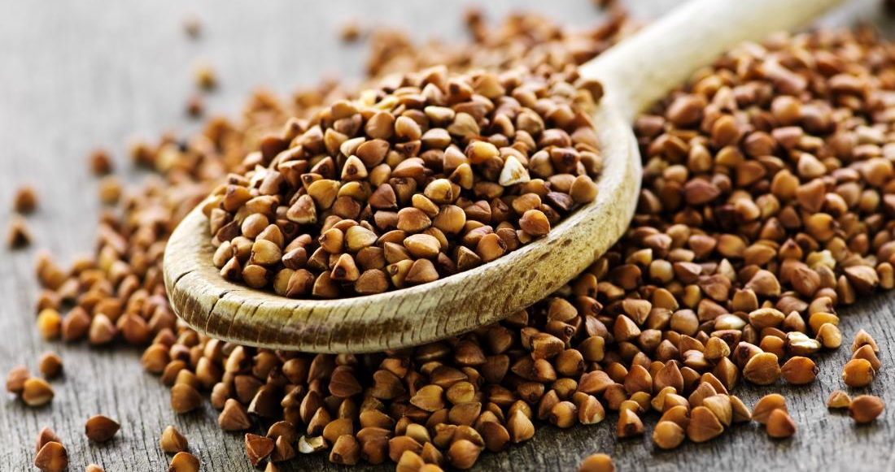
Benefits of Buckwheat
By Stephanie Polizzi, MPH, RDN

You may know buckwheat as an ingredient in pancakes,
but this “whole grain” is actually the seed of the fruit of
the buckwheat plant. It is typically substituted for wheat
since it is gluten-free. But don’t be fooled by the name.
Buckwheat and wheat are not related.

Buckwheat is most valued for its high-quality protein and nutty flavor. One cup cooked buckwheat provides 155 Calories, 6 grams of protein and 5 grams of dietary insoluble fiber. Insoluble fiber helps to move food through the intestines quickly and is associated with lower rates of irritable bowel syndrome (IBS) and reduced bile acid secretion lowering risk of gallstones. Buckwheat also contains resistant starch that helps lower the blood sugar response. Like all plant foods, buckwheat contains no cholesterol.

Buckwheat groats, or hulled kernels, are rich in nutrients that protect against diseases like heart disease, diabetes and cancer. Not only does buckwheat contain all essential amino acids for building protein, it is rich in B vitamins for nerve function and energy production. The mineral content is a powerhouse of magnesium, copper, selenium and zinc that all contribute to strong bones and teeth.

In addition to essential vitamins and minerals, buckwheat also contains important plant compounds that reduce risk of disease. Rutin has been shown to reduce cholesterol and lower risk of heart attack and stroke. Rutin, along with the antioxidants vitamin E and selenium in buckwheat, boost the action of vitamin C to reduce inflammation and protect nerves and other organs from free-radical damage. Lignins, another type of antioxidant in buckwheat, defend against hormone-based cancers like breast cancer.

Buckwheat can be found in most grocery stores as whole groats or ground into flour. Groats can be stored in airtight containers for up to a year. Flour is best stored in the refrigerator or freezer to prevent rancidity. Buckwheat flour has a stronger, nuttier flavor than other flours, and is darker in color. Try swapping some wheat flour at different levels until you find a taste you love. Buckwheat flour can be used in bread or muffin recipes, pancakes or crepes, or mixed with water to make soba noodles.

Enjoy buckwheat groats as a hot breakfast cereal. Add to soups or stews for a chewy texture, or use as a side dish instead of rice or pasta. Cool cooked buckwheat for use in summer salads with vegetables or fruits. Any way you choose, buckwheat is a nutty addition to your healthy diet.

