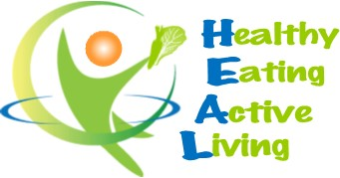
Healthy Bytes Initiative Article
January 2020 Dried Beans

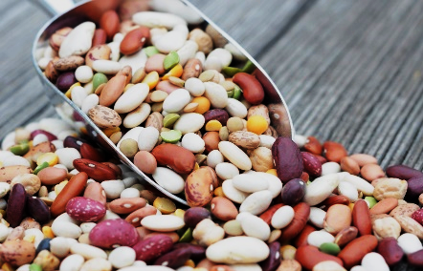
Beans: The Keystone of Health
By Stephanie Polizzi, MPH, RDN

Beans have been cultivated for thousands of years and have
been the mainstay of healthy diets through the ages. In recent
times in the US, beans have lost their place at the table in favor
of a heavy meat diet. But dietitians and physicians who work in
disease reversal know that substituting beans for meat in our mealplans will begin reversing many of the risk factors associated with chronic diseases like cholesterol, blood pressure, blood sugars and body fat.

Beans are inexpensive and loaded with nutrition. There are many varieties from black or pinto beans and lentils to black-eyed or green split peas. Protein and fiber are the two most significant contributions of beans, but their high vitamin and mineral content and low calories makes them the perfect food. They contain very small amounts of fat (unsaturated healthy fat) and no cholesterol, and are a concentrated source of beneficial nutrients that prevent disease, making them the perfect food, especially if you want to save money.

The soluble fiber in beans helps to lower cholesterol and regulate blood sugars, lower blood pressure and inflammation. Fiber helps you feel full so you eat fewer calories, a great bonus if you are trying to lose weight.

Dried beans are actually seeds grown in pods. They must be boiled and cooked until soft before consuming. Soak dried beans in water overnight or for several hours in the refrigerator. Then drain and add water for boiling. This helps to speed cooking time and also may reduce the formation of flatulence (gas). Black-eyed peas and lentils do not require pre-soaking and cook up quickly. Cover beans with water and add herbs or spices. Bring to a boil and reduce heat. Cook until tender: For lentils, about 15 minutes, for dried beans, 45-60 minutes.

When using canned beans, select salt-free varieties. You can rinse beans to remove some of the salt, but you will also remove some of the healthful fiber. Use the gel at the bottom of the can in your cooking since it contains soluble fiber that has escaped from the bean during the canning process. Canned beans contain the same nutrition as dried beans prepared at home. Just be cautious that you read labels to avoid beans with added fats or salts.

Beans can be your soup base, or cooked and mashed to make burgers, dips or spreads. Hummus is traditionally made from chick peas (garbanzo beans) but you can make hummus from any bean. Toss cooked beans on salad or use as a side dish. If beans are a new addition to your diet, do not be concerned about gas, as your body will become accustomed. Flatulence is a sign that your healthy bacteria are helping to release additional nutrition from the beans. Also be sure to drink plenty of water when increasing fiber in your diet.

