Healthy Bytes Initiative Article
July 2020 Mango

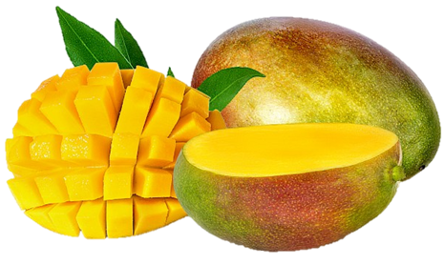
Magnificent Mango
By Stephanie Polizzi, MPH, RDN, DipACLM

The tropical mango fruit is lush and sweet, and a great
addition to your healthy diet. They have been cultivated in
India for over 4,000 years are also grown in the Caribbean, China, Italy, Brazil and Mexico. They come in many varieties with a range of skin colors from green, to orange or red, or a combination of all three. The inside is a creamy, yellow-orange flesh with a large stone or pit. It is not only delicious but also boasts an impressive nutrition profile. This could be why mangos are called “The King of Fruits.”

The most notable nutrient in a mango is vitamin C. One serving (1 cup cubed) has nearly three quarters of the daily vitamin C requirement. The bright color indicates it is also an excellent source of beta-carotene, vitamin E and polyphenols, also known antioxidants. Together, these pack a powerful antioxidant punch that protects against free radicals that contribute to aging and disease. One polyphenol, mangiferin, is especially powerful and has been called a “super antioxidant.” It is being studied for a potential role in cancer prevention.

Mangos also provide a host of other vitamins including 6 of the 8 B vitamins. These play roles in metabolism, cell growth and creating blood cells, and maintaining a healthy immune system. Vitamin K in mangos is important in blood clotting and helps maintain healthy bones. The potassium and magnesium protect blood vessels and promote lower blood pressure levels. Mangos also contain prebiotic fiber that feeds our healthy gut bacteria and soluble fiber, which is known to regulate blood sugars and lower cholesterol.

Judge ripeness by the feel, not the color. A ripe mango will be firm with a slight give, similar to peaches or avocados. Since they are imported, most mangos are hard and will ripen at home by placing in a closed paper bag at room temperature for 2 days. When cutting into the mango, remember that there is a large pit in the center. You can use a peeler to remove the skin, or leave the skin on. Cut off a small piece of the bottom and set it flat on the cutting board. Slice of ¾ inch sections until you reach the pit and rotate to the other side. Then slice into cubes. If you leave the skin on, you can scoop out the flesh with a spoon. The peel is edible and contains carotenoids, fiber and vitamin E, but is usually removed. Toss the skins into your smoothies for added nutrition.

Fresh mango is delicious but you can also puree for summer drinks or smoothies, or dehydrate into fruit leathers. Commercially dried mango is often treated with chemicals to maintain color.
However you choose to enjoy mango, you’ll get a powerhouse of nutrition and sweetness.

