Healthy Bytes Initiative Article
August 2020 Arugula

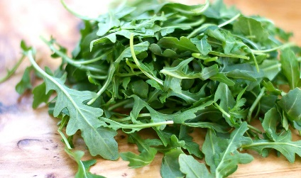
Amazing Arugula
By Stephanie Polizzi, MPH, RDN, DipACLM

Arugula is a tender green in the brassica or cruciferous family.
Its relatives include broccoli, cabbage, Brussels sprouts, kale
and cauliflower. This group of vegetables is celebrated for their
low-calorie, high-nutrient content. Arugula is often used in salads to add a bit of tangy flavor and is a favorite in Mediterranean cooking. It is sometimes referred to as “Rocket.”

Arugula has been part of the human diet for centuries, even mentioned in the Old Testament. It has been used as a raw salad green, usually mixed with other lettuce, but can also be lightly steamed as a side dish, or wilted in hot foods like pasta. In Italy, it is often added as a topping to cooked pizza.

This tangy green contains multiple antioxidants that fight free radicals known to contribute to aging and disease. Vitamin C plays an important role in healing and immunity. Beta-carotene, a compound that contributes to the green color, keeps eyes and skin healthy and protects our DNA. Arugula is also a rich source (provides more than 20% of the Daily Value) of folate, important for fetus brain development, and vitamin K, which supports healthy blood clotting and bone metabolism.

Foods in the cruciferous family are well-known for their Sulphur-containing compounds, known as glucosinolates. Studies show that these compounds, like sulphoraphane, can detoxify carcinogens and inhibit cancer cell growth. Cruciferous vegetable intake is associated with reduced risk of breast, bladder, colorectal, endometrial, gastric, lung, ovarian, pancreatic, prostate and renal cancer. Arugula is also a good source of potassium, calcium and magnesium which all contribute to lower blood pressure and healthy heart rhythm. The nitrates in the raw greens can be used by the body to make nitric oxide, a compound that acts as a vasodilator, lowering blood pressure and improving blood circulation.

Fresh arugula should be bright and green. Store in the refrigerator with a paper towel to absorb excess moisture and use within 2 weeks. Try growing your own from seed. Arugula like full sun or partial shade and loves cool weather so it can be sown from early spring through late summer for a fall and winter growing season. It can be grown in the ground, raised beds or container gardens.

Because of its mild, peppery flavor, it adds a bit of zing, whether used alone or mixed with other salad greens. Add arugula to sandwich layers or chop into hot or cold side dishes. Puree into pesto, dips or spreads, or sauté as a stand-alone side dish. Go to www.allrecipes.com or other recipe sites for tasty arugula recipes.

