Healthy Bytes Initiative Article
May 2021 Non-Dairy Milks

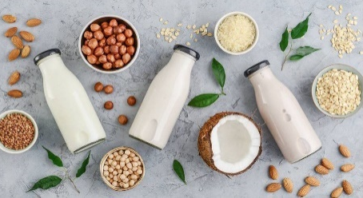
Switching to Non-Dairy Milks
By Stephanie Polizzi, MPH, RDN, DipACLM

Today’s market is bursting with new plant-based dairy alternatives. Non-diary milks (NDMs) can provide healthy alternatives
to cow’s dairy and has a few health advantages. They contain no
saturated fat with the exception of coconut milk. The fat they do
contain is unsaturated, which is associated with improved health.
Some contain omega 3 anti-inflammatory fats. Non-dairy milks also contain phytonutrients that contribute to our health, like antioxidants and fiber.

The variety available to consumers includes milks derived from grains, nuts, seeds, and legumes. The nutrition profile of each of these products varies and choosing among them is dependent on how they are likely to be used.

For example, if you are looking for a protein source, soy milk has a similar protein content to dairy milk. Soy milk has been on the market the longest and contains 7 gm protein, comparable to cow’s milk 8 gm. Besides magnesium, iron and other nutrients, soy is rich in phytoestrogens which are associated with lower blood pressure and LDL cholesterol and decreased risk of heart disease and cancer.

For a flavorful addition for your smoothies or baked goods, choose almond or coconut. Almond milk is lower in protein and carbohydrates but high in flavor. Almonds also contain more calcium than other nuts. Coconuts (seeds) milks can be high in fat so seek out low-fat versions. They have a mild coconut flavor and work well in baking. Other seeds used for making milk include hemp and chia seeds.

Non-dairy milks can also be made from grains. Rice milk is the most commonly used. It lacks protein and fiber and is often found sweetened. Rice milk is a good choice if you have food allergies or sensitivities. If you like cream in your coffee, try oat milk since it is naturally thick and creamy. Oat milk is naturally sweet so it rarely contains added sugars. It is also the easiest to make at home with just original-cooking rolled oats and water.

You can find non-dairy milks in shelf-stable wax cartons on the grocery aisles, usually near the dry cereals, or in the refrigerated section. To meet the US Dietary Guidelines recommendations, reduce added sugars by selecting unsweetened milks. Typically, flavored milks, like vanilla or chocolate, will have added sugars. Read the ingredients labels carefully.

Many non-dairy milks can be made at home with just the main ingredient (nuts, seeds, grains, legumes), water and a high-speed blender. This saves money and allows you to control the added ingredients like sweeteners and flavorings without the added chemicals like thickeners, gums or chemicals. Most milks require straining out the fibrous leftovers to have a smooth, creamy milk. Retain this fiber and add it to porridge, smoothies or baked goods.

Most non-dairy milks have been enriched with calcium and vitamin D. If you are making your own milks, try adding in plant-based sources of calcium. These include broccoli and green leafy vegetables, figs and oranges, almonds and Brazil nuts, tofu and white beans, sesame and chia seeds, blackstrap molasses and grains like teff, sorghum and millet.

