Healthy Bytes Initiative Article
Jun 2021 Teff

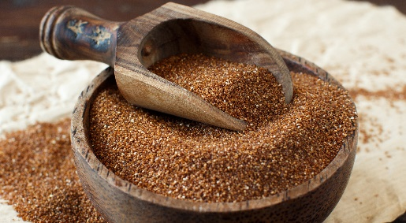
Teff: Tiny Grain, Big Nutrition
By Stephanie Polizzi, MPH, RDN, DipACLM

Teff is an ancient grain in the millet family. This grain (technically
a seed) is the tiniest in the world, smaller than a poppy seed, but
provides big benefits in nutrition. Its name comes from the Amharic
word “lost” since it is so small, much of it is often lost in harvesting.
Because it is too small to mill, all varieties of teff are whole grain.
Teff varieties include grains from white to reddish brown that share a mild, nutty flavor.

Teff is native to Ethiopia, a country, famous for its long-distance runners. Teff is a staple in Ethiopian diets, providing 70% of calories and 2/3 of daily protein. This grain is an excellence source of protein and contains lysine, the amino acid often missing in grains. Lysine is essential for the production of proteins, hormones, enzymes, collagen and elastin. Lysine also supports calcium absorption, energy production and immune function. A protein missing from teff is gluten. Teff is a delicious and nutritious addition to a gluten-free lifestyle.

Teff is also an excellent source of iron. Even conservative estimates indicate teff is a better source of iron than most other grains. For example, 3.5 oz (100gm) of teff flour provides 37% of the Daily Value (DV) for iron, while the same amount of wheat flour offers 5%. Teff also provides more calcium than most other grains. A 3/4 cup serving of teff porridge contains about 87 mg of calcium vs 16 mg in 3/4 cup cooked oatmeal. A 3/4 cup cooked teff serving also provides 22% DV of magnesium, 12% DV of zinc and 223% DV of manganese.

As a whole grain, teff also contains 8 grams of fiber per cup cooked, and has only 3% fat, which make it an excellent grain to build into your menu plans. Teff can be purchased as a whole grain or ground into flour. The whole grains can be used in baking. Just add uncooked teff to muffin or cake recipes like you would add nuts or seeds. It can also be added to soups or stews as a thickener. Whole teff makes a tasty breakfast porridge and cooks in just 15 minutes. Teff can also be used to make polenta. Toss cooked teff into roasted vegetables or on green salads for a boost of nutrition.

Teff flour can be substituted for wheat flour but since it lacks gluten, it requires some binder like xanthan gum. This step can be avoided if substituting 50% teff for wheat flour.

Teff is an ancient and exotic grain and yet it can be found at most grocery stores that carry Bob’s Red Mill products. Due to the difficulty harvesting, teff can cost a little more than wheat or oats, about $5 for a 1-pound bag of whole teff. The small grain goes a long way. Add ½ cup teff to 2 cups boiling water and simmer 15-20 minutes for 2-3 servings of porridge. Store leftovers in the fridge up to 5 days. Keep teff grains and flour in the refrigerator or freezer in a tightly sealed container.

Adding a variety of whole grains to your diet will provide an abundance of nutritious vitamins, minerals and fiber, that protect us from disease. Teff also provides a good source of protein and iron, and a nutty flavor that is a great addition to any meal or snack.

