Healthy Bytes Initiative Article
Jan 2022 Avocados

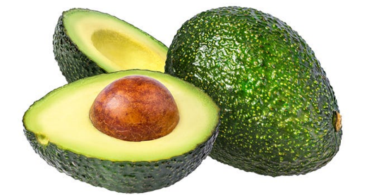
Amazing Avocados
By Stephanie Polizzi, MPH, RDN, DipACLM

Avocados are a wholesome way to consume healthy fats along with vitamins, minerals, phytonutrients and fiber. Like most fruit, an avocado is a good source of antioxidants and healthy phytonutrients. But unlike most fruit, the avocado is low in sugar and high in fat.

Avocados are a rich source of antioxidants including vitamins C and E that protect against cellular damage caused by free radicals. These vitamins help with wound-healing and boost immunity. Other antioxidants like the carotenoids lutein and zeaxanthin contribute to eye health, reducing risk of cataracts and macular degeneration. Avocados also contain several B vitamins important for energy production and a significant amount of folate, a B vitamin essential for DNA formation, cell division and prevention of anemia. Vitamin K is a fat-soluble vitamin responsible for blood clotting and bone health.

Besides vitamins, avocados are rich in minerals. Potassium is responsible for the regulation of blood pressure and heart health and avocados have more potassium than a banana. Copper is an essential mineral involved in energy production, iron metabolism, brain development and immune function. Avocados also contain magnesium important for muscle and nerve function, blood glucose control, energy production, bone and DNA synthesis and maintaining heart rhythm. They also contain small amounts of iron and calcium.

Avocados also contribute healthy unsaturated fats and both soluble and insoluble fiber. Their unique composition of fat and water content help the body to absorb both water-soluble and fat-soluble vitamins. The avocado has been shown to help lower blood pressure, improve glucose control and reduce risk of heart disease and stroke.

When shopping for avocados, they are often hard and unripe. Bring them home and place in a paper bag, allowing 3-4 days for ripening. Adding a banana or apple may speed the process. A ripe avocado will yield to a gentle squeeze. Store ripe or soft avocados in the refrigerator and use within 1-2 days.

Slice the avocado skin lengthwise all the way around and twist the two halves to open. Pry the seed out with a spoon or hit the seed with a sharp knife and twist the seed out. Toss chopped or sliced avocado in salads, sandwiches, vegetables or smoothies. Mash with potatoes or spread on toast.

Avocados are a great way to get healthy fats, vitamins, minerals and other plant compounds that protect the body from aging and chronic disease, especially if you substitute them for saturated fats in your diet. The texture and flavor of the avocado make it a healthy, whole food substitute for butter, mayonnaise or oil in cooking, baking and food preparation. Use instead of oil or mayo in salad dressings or as a butter substitute in baked goods.

