Healthy Bytes Initiative Article
May 2022 Apricots

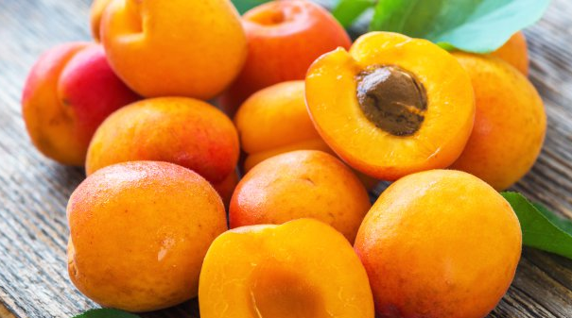
Health Benefits of Apricots
By Stephanie Polizzi, MPH, RDN, DipACLM

Apricots are a member of the stone fruit or drupe family which includes peaches, plums, cherries, nectarines and olives. These fruits each have a large stone or pit inside. Apricots have a soft, velvety skin, with sweet flesh that is not overly juicy. Most apricots in the US come from California orchards.

Apricots are rich in antioxidants, which include beta-carotene, vitamins C, E, K and polyphenols. They also have many other antioxidant compounds like quercetin, catechins and epicatechins, and gallic acid.
Beta-carotene, lutein and zeaxanthin help protect eyesight against age-related damage and blindness. Catechins, like those found in green tea, have anti-inflammatory properties and may help to control high blood pressure. Apricots are one of the best sources of potassium which is important for nerve transmission and lowering blood pressure. It is also essential for muscle contraction, including the heart muscle, and for maintaining kidney function. One half cup of dried apricots has 679 more grams of potassium than one banana.

A serving of apricots provides 2 grams of fiber, which contributes to the minimum recommendation of 25-38 gm/day. Apricots contain soluble fiber, known to modulate blood sugars and lower cholesterol. Soluble fiber also feeds our healthy gut bacteria and improves our immune system. Insoluble fiber in apricots helps to move food through the digestive tract and may prevent some forms of cancer.

Ripe apricots are dark orange and slightly soft with a fragrant aroma. Since the skins are edible, it is recommended to select apricots displaying the USDA organic label when possible. If unable to use fresh apricots right away, they can be frozen. Store ripe apricots in the refrigerator unwashed. Wash just before slicing around the seam of the apricot and twist halves to remove the stone. Add to smoothies and salads, fill halves with yogurt and nuts, or just enjoy plain. Try fresh or frozen in margaritas.

Dried apricots are often packaged with added sugars and sulfur dioxide to preserve color, which can cause allergic reactions. Select unsulfured dried fruit with no added sugars. Toss in cereal, yogurt or salads or chop into trail mix. Rehydrate dried apricots by pouring boiling water over them and letting them sit for 5 minutes. Then add to stir fry vegetables or mashed potatoes. Winter apricots can be less sweet and are often used in making jams, jellies and syrups. Use fresh or frozen winter apricots for these preparations. You can also add these to soups and stews.

Try substituting apricots for strawberries in shortcake or add to fruit salads. You can even grill fresh apricot halves and serve with savory dishes. Kids love to snack on them since they are “fun size” just for them. However you enjoy apricots, you are sure to get great nutrition and deliciousness.

