Healthy Bytes Initiative Article
July 2022 Peaches

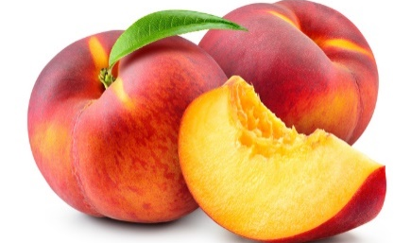

Health Benefits of Peaches
By Brittany Whiteman, MPH
Dietetic Intern, Oakwood University

There is nothing better than a peach during summer. Peaches originate in China, where it is seen as a symbol of long life and immortality. Peaches spread from China, to Persia and then to Europe. It is believed that Spanish missionaries brought peaches to the Americas. In the US, the first peach tree was planted in Florida in the early 1500s. Peach production is currently highest in California and South Carolina.
A peach is a stone fruit because of the pit or stone in the middle of the fruit. Peaches are classified as either clingstone or freestone. As the names suggest, the pit either “clings” or is “freely” separated from the flesh of fruit. Although there are hundreds of varieties of peaches, its flesh is mainly categorized as yellow or white. The skin of the peach can be dark red, blush/pink and yellow. Most peaches produced are consumed fresh, while some are sold canned, frozen, dried, or processed to make peach drinks, jelly and candy. For canned peaches, it is best to choose the variety in water instead of syrup due to the high amounts of added sugars.
Peaches are a good source of vitamin C. It provides approximately 13% of vitamin C, 3% of vitamin A and 2% or more Daily Value of vitamins E, K and B3 (niacin). Peaches contain potassium, copper, manganese, small amounts of magnesium, phosphorus, and iron. These minerals are all needed in our bodies to support our bones, immune system, heart and other organs, aid in digestion and to carry out many other functions. One medium peach provides approximately 9% of the daily fiber intake recommendation for women, and 6% for men under 50 years of age. Eating the skin on the fruit maximizes fiber and phytonutrient intake. The flesh and skin of peaches contain antioxidants like carotenoids and polyphenols that are essential for eye health, immune function, disease prevention and many other health benefits.
Peaches can be bought at farmers markets, grocery stores and other locations. While these fruits can be found in fine quality from April through October, they are usually best during the summer season. It is recommended to purchase peaches with the USDA organic label when possible. Peaches can be stored on the counter at room temperature until they are at your preferred ripeness if they were bought unripe. When ripe enough, peaches can be stored in the refrigerator where they will last up to five days. Peaches can also be kept frozen for later use, where they will last at least 6 months. Always remember to wash peaches well under running water and rub with a paper towel before consuming. To prevent browning caused by oxidation after peeling, sliced or chopped peaches can be tossed with lemon juice as a preventative measure.
Peaches can be used in a variety of ways in all kinds of dishes. They can be used fresh, canned, frozen, and dried, as an easy addition to baked goods, smoothies, salads, drinks, and as a topping. They can be added to sorbets, popsicles and other cold drinks or frozen treats. They are also used to make peach jam or jelly, added to soups, salsa, relish, different sauces and even added on skewers for fruit kebabs.
Peaches are quite versatile and add a delightful flavor to dishes, with the added bonus of health benefits. Be on the lookout for peaches on your next food shopping trip.

