Healthy Bytes Initiative Article
Sep 2022 Swiss Chard

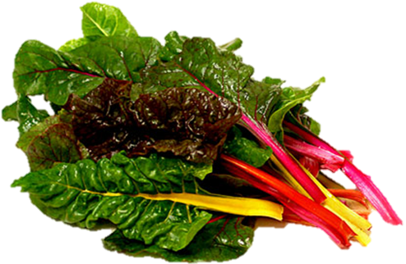

Health Benefits of Swiss Chard
By Stephanie Polizzi, MPH, RDN

Swiss chard is a member of the beet family, which accounts
for its red stems and veins. Like beets, it is helpful in lowering blood
pressure and improving blood flow. Chard is rich in vitamins, minerals
and phytonutrients like antioxidants that fight disease and aging.

Like other greens, Swiss chard contains several antioxidants including beta-carotene and vitamins C and K. Vitamin K helps make proteins required for blood clotting and the building of bone while lutein and zeaxanthin maintain eye health. Chard also contains B vitamins thiamin, riboflavin, niacin, B6 and pantothenic acid for energy production and healthy skin.

Some may feel confused if they are being prescribed blood thinners by their primary care providers and warned to reduce intake of vitamin K. Although vitamin K consumption can interfere with the effectiveness of blood-thinning medications, you can still enjoy Swiss chard. The goal is to maintain a steady intake of greens so your provider can make adjustments to the medication strength.

Swiss chard contains calcium and magnesium which work with vitamin K to maintain bone health and reduce risk of fractures. Chard also contains phosphorus, zinc and selenium (antioxidant). Although minimal, the fiber in Swiss chard can help reduce constipation, hemorrhoids, and aid in weight control. Cooked Swiss chard shrinks greatly in size, making it easier to consume larger quantities and increase fiber intake.

The high level of beneficial nitrates in Swiss chard provides compounds for the body’s production of nitric oxide (NO), a gas produced in the blood vessels and other organs responsible for widening arteries and lowering blood pressure. NO can also improve blood flow, lower cholesterol and prevent the
build-up of artery-clogging plaque.

Nitric oxide has also been shown to improve oxygen transport in muscles during exercise, resulting in longer endurance and improved athletic performance.

Chlorophyll in Swiss chard may help to block carcinogens created when cooking meats at high temperatures like grilling or frying. Kaempferol is anti-inflammatory and my also prevent cancer cell formation. Alpha-lipoic acid in Swiss chard has been shown to assist in lowering blood sugars and improving insulin sensitivity.

When buying Swiss chard, seek out bunches with firm, dark leaves. Stems can range from deep red to orange and yellow. Both leaves and stems are equally edible and nutritious. Store unwashed in the refrigerator until ready for use. Rinse well and shake off excess water before use. Mature chard can have a slightly bitter taste. Lightly sautéing can reduce bitterness, as does adding lemon juice to raw or cooked chard.

Use Swiss chard like other greens by adding to salad mix, on sandwiches or in smoothies. Wilt into hot soup or toss into stir fried veggies. Try using Swiss chard in place of basil when making pesto or pickle stems for a crunchy snack. Swiss chard is another healthy leafy green you can add to your menu planning.

