Healthy Bytes Initiative Article
October 2019 Pears

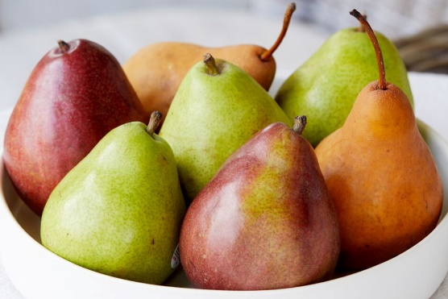
Power of Pears
By Stephanie Polizzi, MPH, RDN

Pears have always held a place of status throughout
history. The Greek poet, Homer, referred to them as a
“gift of the gods.” Since they can be stored for long
periods, like apples, pears were carried on trading routes
and brought to Oregon by pioneers in the 1800’s. Today’s
pear varieties include Bosc and Comice, mainly grown in the Pacific Northwest, as well as Bartlett, Anjou (red and green) and the Asian pear, which is shaped more like an apple. Lesser-known varieties include Royal Riviera, Taylor’s Golden and Forelle, famous for their “freckles.” Some sources say there are more than 3,000 varieties of pears around the world.

Pears can range in colors from yellow and gold, to red, green and brown. The darker the pear, the more polyphenol antioxidant content. But don’t let that stop you from trying all different pears this fall. Pears are usually found in our markets in an unripe state and may not have taken on their final colors until you take them home and allow them to ripen fully.

When shopping for pears, choose those that are firm and free of bruises. Store in paper bags at room temperature until they ripen, but watch them closely since they can quickly turn mushy. Once they ripen, store in the refrigerator in tightly-fitting bags or containers since these delicate fruit can absorb stronger smelling foods. Wash well, remove cores and slice for eating. Be sure to retain the skin since much of the healthful nutrients reside there. Recent studies show the skins of pears contain 3-4 times as much nutrients as the inside and about half the pear’s fiber. When possible, select organic produce if you intend to consume the skins.

One medium pear contains 6 grams of fiber, 200 mg of potassium, and 12% of your daily vitamin C. Studies conducted on women with diabetes show pears contain a flavonoid (antioxidant) that can improve insulin sensitivity. The well-respected Nurse’s Health Study shows that a combination of apples and pears lowered risk for developing type 2 diabetes. This could be related to their content of soluble fiber, which not only regulates blood sugars, but helps lower cholesterol. Pear fiber can also bind with bile acids, particularly those associated with risk for colorectal cancer. Pears may also reduce risk of stomach and esophageal cancers.

Pears are a low-allergy food and are easy to digest. This is why pears are one of the first solid foods introduced to babies. Slice pears into salads, breakfast cereals (hot or cold) and yogurt, or toss into vegetable side dishes. They’re great in coleslaw or even on sandwiches. Overripe pears can be tossed into smoothies, blended into a salad dressing, or spread on your dehydrator to make fruit leather. Freeze overripe pears and add to your cranberry sauce this Thanksgiving. You’ll have sweet sauce without added sugar.

