Healthy Bytes Initiative Article
December 2019 Bell Peppers

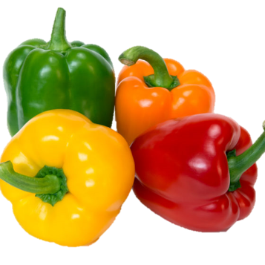
Sweet Bell Peppers
By Stephanie Polizzi, MPH, RDN

Although some peppers can be spicy or fiery hot, bell peppers fall
into the sweet pepper category. Although we call them vegetables,
they are really fruit. Bell peppers start out naturally as green and
gradually mature, moving from yellow to orange then red, depending
on how long they stay on the vine. This means the color determines
ripeness. The more ripened the bell pepper, the sweeter the flavor.

Bell peppers contain a wide variety of phytonutrients, plant compounds that protect the plant from illness and injury. When we consume these compounds, they work to protect our bodies as well. Bell peppers contain large amounts of antioxidants, including beta-carotene and lutenoid which help maintain eye health. They provide more than 200% the daily value for vitamin C which helps ward off seasonal colds and protects our tissues from damage and aging. They also contain B vitamins, including folate important for pregnant mothers. They are low in calories and high in flavor. Their anti-inflammatory properties help reduce joint and muscle pain (orange and red only). One bell pepper has at least 2 grams of dietary fiber.

Bell peppers are a member of the nightshade family which also includes potatoes, eggplant, and goji berries. If you suffer from joint pain and have tried everything else, you may want to avoid nightshade vegetables for 30 days. If you improve, you may be sensitive to the nightshade family.

You may also be someone who experiences indigestion or burping when consuming bell peppers. This is often a result of eating green or immature peppers. Try using the orange or red peppers instead and see if your symptoms improve.

When shopping for peppers, look for those with a thick, shiny skin and green stems. Red peppers have the sweetest flavor but, due to the longer ripening, may also carry the highest price tag. Shop at farmers’ markets or local grocers for the best price. Store in the refrigerator for up to a week. To prepare peppers, remove stems, core and seeds (seeds tend to be spicier) and slice into desired size. Wrap cut pieces tightly in plastic wrap and they will last up to 3 days in the refrigerator. You can also spread chopped peppers on a cookie sheet and freeze. Once frozen, move into containers and keep in your freezer. This allows you to select just the right amount for a quick stir-fry or soup.

Bell peppers can be consumed raw or cooked. Try serving raw bell pepper slices or chunks with hummus dip, or slice into rings in salads or on sandwiches. Top pizza or add to fresh salsa. Roast peppers with onions and green beans for a festive holiday side dish. Skewer in kabobs or chop into soups, stews, pasta sauce, rice dishes or burger mixes. Stuffed peppers are a simple and delicious holiday meal that can be prepared ahead of time. Just stuff whole peppers with wild rice and zucchini and roast until soft. Top with tomato sauce or gravy.

