Healthy Bytes Initiative Article
April 2020 Millet

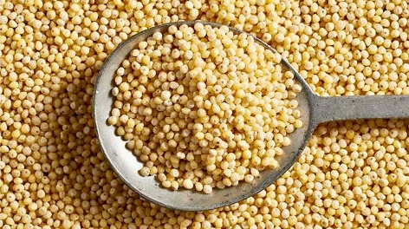
Grainy Goodness of Millet
By Stephanie Polizzi, MPH, RDN

Millet is among our most ancient grains, consumed by our ancestors for more than 10,000 years in China, Japan, India, Greece and Africa. Millet is not one grain, but a group of grasses with small seeds of which there are many different species. The varieties most often used today include pearl, finger, proso and foxtail varieties, with the most common being pearl millet. In the US, millet is a nearly-forgotten grain, most often used in birdseed. Today’s diets lack variety, and these wholesome grains, that have fueled mankind for centuries, are worthy of a revival.
Studies show that intake of a variety of whole grains is protective against cardiovascular disease, type 2 diabetes and several gastrointestinal cancers. Millet varieties contain antioxidants like vitamins C, E, K, selenium and polyphenols that protect against development of free radicals that can accelerate aging and disease. They are a good source of both soluble and insoluble dietary fiber, B vitamins and minerals like calcium, iron and magnesium, packing a giant nutritional punch in a small portion.
All millet varieties are naturally gluten free, but one type, sorghum, is often ground into flour for use in gluten-free recipes. Like other grains, millet can also be fermented to make alcohols. In Russia, millet is consumed as a breakfast porridge. In China, it is mixed with beans, sweet potato and squash. In India, millet is used to make flatbreads.
Here at home, millet can be cooked up in a variety of ways to achieve different textures. Being a small seed, it can be toasted by tossing small amounts in a dry pan for 3-5 minutes, stirring constantly. This brings out the nutty flavor but is not a necessary step to cooking. Boil 1 cup millet with 2 cups water for a whole grain side dish. Increase the water to 3 cups to 1 cup millet for a creamy porridge. Being a small seed similar to quinoa, millet cooks in about 15 minutes.
Millet can be found in most grocery stores in its intact form, small yellow or reddish seeds, in packages or in bulk, whole grain or husked. These grains can be stored in an airtight container for several months. Because of their oil content, they will go rancid quickly and should be stored in the refrigerator or freezer until ready to use.
When it comes to a healthy diet, grains should be nutrient-dense and used in smaller portions since they can be high in Calories. Be adventurous and seek out new ways to include millet and other ancient grains by trying ethnic recipes from India, Africa and China. Try substituting millet for an old standby like cream of wheat or oatmeal and have a culinary adventure. Millet was once revered by our ancestors, and should be again. It is time to take back our birdseed and share this ancient jewel with our friends and family.

