Healthy Bytes Initiative Article
May 2020 Kiwi

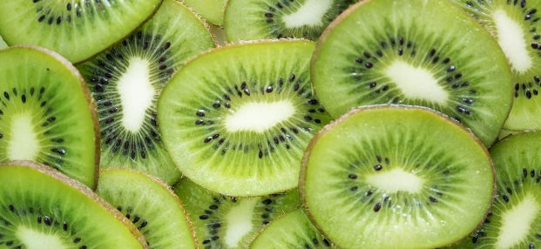
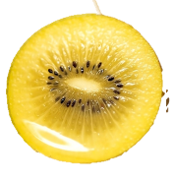
Kiwi or Kiwifruit
By Stephanie Polizzi, MPH, RDN, CLMP

Kiwi, also known as kiwifruit, are sweet and delicious treats in

green or yellow varieties. Best known for their high vitamin C,

they also play a role in digestive and heart health. Kiwi contain

three times the amount of vitamin C than a serving of orange or strawberries and half the sugar of an apple.

Native to the hills of southwest China, kiwi were called the Chinese Gooseberry but were renamed kiwifruit after the New Zealand bird native to today’s major producer. The Hayward variety of kiwi are known for their brown hairy skins, bright green interior and tangy flavor. The SunGold variety has a bright yellow interior, sweet flavor and smooth, edible skin. Consuming the skins of yellow kiwi increases nutrient content of vitamin E, folate and fiber by 32, 34 and 50%, respectively. Despite the sweet taste, kiwi have a low glycemic index, making them a great choice for keeping blood sugars low.

Kiwi are packed with nutrition. Most notably, vitamin C, which protects against free radicals that can lead to aging and disease, builds collagen for healthy skin and connective tissue, improves immunity and increases iron absorption. Lutein, zeaxanthin and vitamin E antioxidants protect against macular degeneration to maintain eye health as we age. Other antioxidants include beta-carotene and selenium. In addition, kiwi also contain serotonin which helps with sleep, mood and appetite regulation.

Both soluble and insoluble fiber in kiwi feed healthy gut bacteria which produce short chain fatty acids (SCFA). These are known to protect against inflammation, heart disease and diabetes. Besides the fiber, kiwi also contain natural enzymes which help break down proteins and facilitate digestion.

When selecting ripe kiwi, size is not related to quality. Ripe kiwi will yield to gently pressure, but hard kiwi will ripen if stored at room temperature away from sunlight. Place unripe kiwi in a paper bag with apple or banana to speed the ripening process. The skins of all kiwi varieties are edible, but most peel the hairy skin of green kiwi with a paring knife, or cut in half and scoop out flesh with a spoon. Retain the smooth skin of the yellow variety for added nutrition. Purchase organic kiwi if you intend to consume the skins.

Slice ripe kiwi into green or fruit salads, or toss into smoothies. Puree kiwi and add to soups, sauces, salsa or dressings, or dehydrate to make tasty fruit leathers. Kiwi has the unique feature of retaining much of its vitamin C after cutting, so it is a great option for slicing in advance for lunches or snacking and a healthy addition to your family’s diet.

