Healthy Bytes Initiative Article
2022 Dec Figs

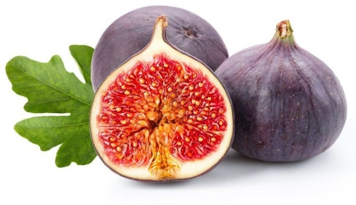
Health Benefits of Figs
By Ayda Ayob, BS, Dietetic Intern

Figs are a soft, bell-shaped fruit with succulent flesh from the Ficus tree, which is part of the mulberry plant family. They have a unique sweet taste and chewy texture. They are a good source of carbohydrates, fiber, minerals, and vitamins. They also contain antioxidants and phytochemicals that are beneficial for prevention of diseases like heart disease, diabetes and cancer.
Fig trees mainly thrive in the tropic and subtropics areas, with mostly warm weather and mild winter. They range from green (early ripeness) to purple and brown (fully ripened). Unless you have a tree in your backyard, it can be difficult to catch a fig at peak ripeness. Fresh figs are also delicate and very perishable. They may only last five to seven days after being picked and refrigeration can prolong the shelf life up to two weeks. This is one of the reasons why dried figs are more common in the market. You can find both fresh and dried figs at your local farmers market or grocery store depending on your region and time of the year.
Figs are naturally low in calories and have zero cholesterol, fat, and sodium. Both fresh and dried figs have high amounts of fiber. The soluble fiber acts as a sponge to absorb cholesterol in the blood to prevent progression of heart disease, while the insoluble fiber acts as laxative to help with constipation. Figs also have a low glycemic index, and the soluble fiber slows the absorption of sugar into the blood.
The main phytochemicals found in both fresh and dried figs are phenolic acids and flavonoids. The concentration of these compounds varies depending on the color, fruit part, ripeness, and drying process of the fruit. Phenolic acids and flavonoids have anti-inflammatory and antioxidant properties that help to protect cells from free radicals that may lead to cancer.
Dried figs are an excellent source of calcium, potassium, and phosphorus that is essential for maintaining healthy bones. Strontium (Sr) is another mineral compound found to be relatively high in figs that is great for bone health and it is used as an anti-osteoporotic agent in postmenopausal osteoporosis medication. Figs also contain iron, which is important in the formation of red blood cells in our body, and copper, which help to maintain brain function and the immune system.
Main vitamins found in figs includes beta carotenes that can help to maintain healthy vision, skin, and immune system. Vitamin K is also abundant in figs, which helps with the clotting factor in blood. If people are prescribed blood-thinners or anticoagulant medication, food high in vitamin K can interfere with the effectiveness of the medication. Thus, consistent intake of vitamin K-rich food should be monitored.
Figs can be enjoyed fresh or dried. Try tossing into salads or smoothies or adding sliced figs to your favorite pizza. Ripe and juicy figs are ideal for homemade jam or chutney. Consider having dried figs as your on-the-go snacks for energy boost and sweets cravings.
However you choose to use figs, they are a healthy addition to a heart-healthy Mediterranean diet because of their cholesterol-lowering and blood-sugar stabilizing benefits.

