Healthy Bytes Initiative Article
February 2020 Eggplant

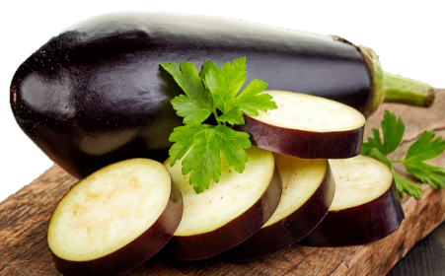
Regal, Rewarding Eggplant
By Stephanie Polizzi, MPH, RDN
https://snaped.fns.usda.gov/seasonal-produce-guide/eggplant

Eggplants are glossy, deep purple gems rich in the royal color of kings and in good nutrition. Grown thousands of years ago in India and China, this obscure culinary delight boasts a spongy center, edible seeds in a conical pattern and mild flavor. A member of the nightshade family, along with tomatoes, bell peppers and potatoes, they grow from vines that can grow to be several feet tall. Like tomatoes, eggplants are actually fruit, not vegetables, sometimes referred to as “flowering vegetables.” Maligned for their mildly bitter taste, the compounds responsible are among the most beneficial to our health. Recent cultivations have improved the flavor without destroying the benefits. In addition to the deep purple variety, eggplant is also available in a range of other colors from green and lavender to orange and yellow. They can also range in size from that of a small tomato to a large zucchini.
Eggplants are a rich source of antioxidants that protect our cells from oxidative damage, reducing our risk for heart disease, diabetes and cancer. Anthocyanins are compounds responsible for the rich, purple color, and are some of the most powerful antioxidants. Eggplants also contain vitamins B, C, E and K, minerals copper, magnesium, potassium and fiber, all of which work together to protect our cells and maintain proper heart function. Another antioxidant called nasunin has been shown to protect brain cell membranes, fighting memory loss and dementia. Recent studies have found potential anticancer uses for compounds called solasodine rhamnosyl glycosides found in eggplant. Eggplant is also good for your eyes. It contains lutein and zeaxanthin, antioxidants know to prevent age-related macular degeneration.
When shopping for eggplant, choose heavy, firm bulbs, with smooth, shiny skin. The stem should be bright green. Skin that springs back after gentle pressure indicates ripeness. Select un-waxed and organic when possible since you can consume the skins. Eggplants are very perishable so store unwashed, uncut and unwrapped, in the refrigerator. Before using, wash and remove both ends using a stainless steel knife. Eggplant can be baked whole or diced, roasted or steamed. Sometimes, “sweating” is recommended. To sweat, sprinkle cut eggplant with a small amount of salt and let rest 30 minutes. Then rinse and dry before preparation. Sweating will help reduce any residual bitter flavor and oil absorption.
Try raw eggplant chunks in salad or puree grilled eggplant for dips or sandwich spreads. Add to stir-fry dishes or grill them in slices for burger toppings. Toss into pasta dishes or slice thin and use in place of noodles in lasagna. Slices can even be used in place of pizza dough. However you choose to enjoy eggplant, you can be confident you are providing a healthy option for yourself and your family.

